EENG 385 - Electronic Devices and Circuits

Frequency Domain: Active Filters

Lab Handout

# Objective

The objective of this lab is to study the design of the filters on the audio board and measure their performance.

**Filter Background**

# You have should have designed and tested your filters in the previous steps and are now ready to construct them. The architecture of the filters you designed matches the architecture of the filters that are on your Audio Board, shown in Figure 1.

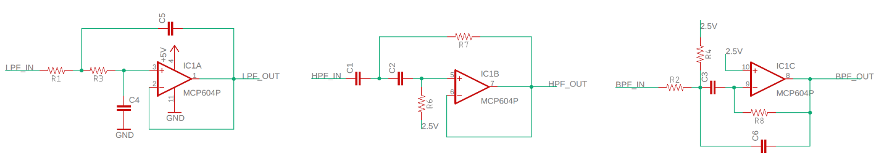

Figure : The Audio board comes setup with three filters. From left to right, low pass, high pass and band pass. Your task in this lab is to select component value to achieve specific performance goals.

In order to assemble your filters, you need to take the relate the components values you found in the design phase to those in the schematic of the Audio Board. Take the low pass filter shown in Figure 2. The resistor identified as R1A, 150kΩ, should be placed in component position R1 on the Audio Board.

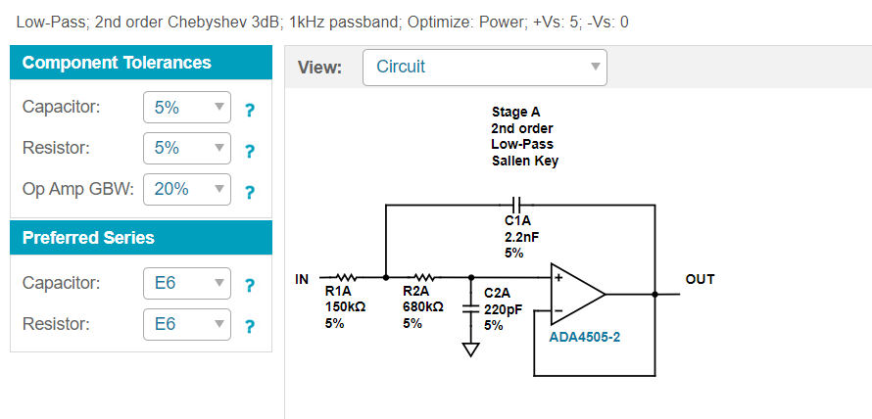

Figure : An example low pass filter, this is NOT the filter you should construct.

**Construction of Filters**

You will need to hunt down components for your filters using the parts available to you in the blue cabinet in Brown 304. Since we do not have an unlimited variety of resistor and capacitor values you may need to create an equivalent component value.

As described in the **How To: Design Wizard** section, you can limit the component values used by selecting an E series. The number adjacent to “E” denoted the number of different component values per decade. If you get a filter design that requires a resistor or capacitor that we do not stock, it’s time to craft an equivalent component by combining 2 or more components in parallel.

When you put two resistors in parallel, the resulting resistance is smaller than either of the component resistors using the familiar resistors in parallel equation. When you put two capacitors in parallel, the resulting capacitance is the sum of the component capacitors. In either case, if you are trying to create a specific component value you have two unknowns, so this process is a lot of guess-and-check. I made up a quick Excel spreadsheet that computes the parallel combination of the resistor in the top row with the resistor in the left column.

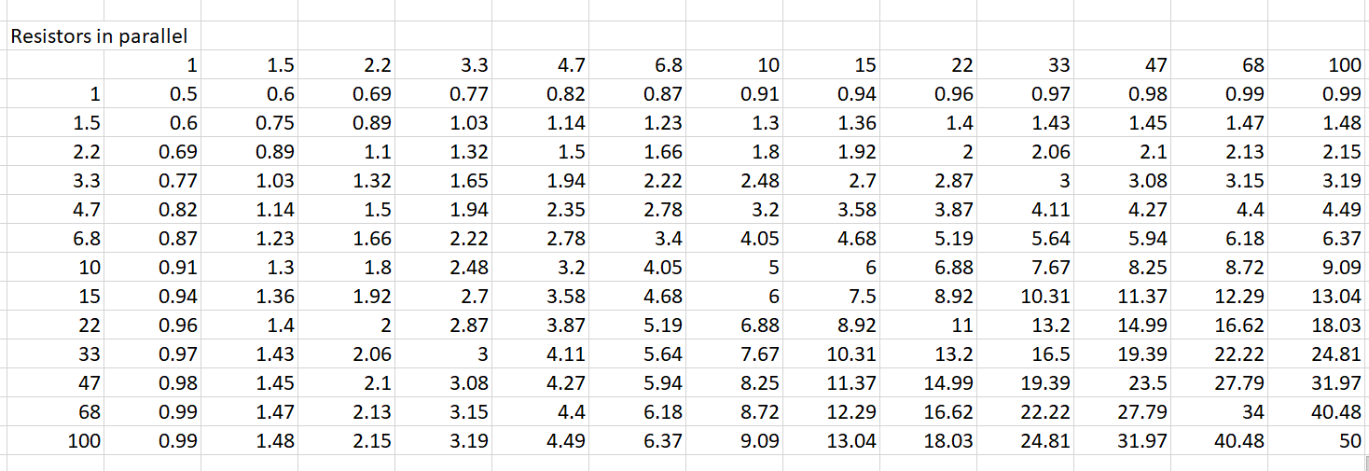

For example, say you needed a 4.7kΩ resistor but we did not have any in stock. Well, you could combine a 6.8kΩ resistor in parallel with a 15kΩ resistor producing an equivalent 4.68kΩ resistor. Note, it is unlikely that you will be able to create a combination that exactly produces the resistor value that you need. In that case you should get as close as you can.

You will need to construct your own Capacitors in parallel Excel worksheet if you need capacitors that are not in stock.

Finally, please take advantage of the component tester on top of the blue parts cabinet in Brown 304 to verify the component values of the parts you pulled out a bin. Often components end-up in incorrect bins when they are returned. It’s much easier to replace a capacitor that hasn’t been soldered into the Audio Board.